



DOCUMENTATION

COMMUNICATION

THIS SECTION BRIEFLY DESCRIBES ABOUT THE NEED,THE FEATURES AND THE FUNCTIONALITIES REQUIRED BY THE CUSTOMER

**OBJECTIVE**

THE MAIN OBJECTIVE OF THE CUSTOMER IS TO WORK FOR THE SOCIAL DEVELOPMENT OF UNDERPRIVILEGED INDIVIDUALS,GROUPS AND COMMUNITIES WITH THE HELP OF A PLATFORM WHERE THERE CAN BE BUYING AND SELLING OF USED PRODUCTS.

THE PLATFORM SHOULD ENCOURAGE INDIVIDUALS

TO WORK FOR SOCIAL AND ECONOMIC EMPOWERMENT OF NEEDY PEOPLE.

USERS THOSE WHO THINK RATHER THAN GIVING AWAY OF USED PRODUCTS IN GARBAGE THAT ARE IN A CONDITION THAT IT CAN BE REUSED,

CAN SELL IT TO NEEDY INDIVIDUALS OR ORGANISATIONS AT A MINIMUM COST.

AS A SELLER ONE CAN POST AN ADVERTISEMENT TO SELL USED PRODUCTS ON THE PORTAL AND AS A BUYER

(CAN BE AN INDIVIDUAL OR STAKEHOLDER OF NON-PROFIT ORGANISATION)

CAN BUY THOSE PRODUCTS.

**FEATURES AND FUNCTIONALITIES**

**TO BE INCLUDED IN THE PROJECT**

1. USER AS A BUYER CAN ACCESS THE PORTAL AND CAN BUY PRODUCTS

1. USER AS A SELLER CAN PUT UP THEIR ADVERTISEMENT ON THE PORTAL TO SELL PRODUCTS
2. SECURED PAYMENT GATEWAY SO THAT MONEY CAN DIRECTLY GET TRANSFERRED FROM THE BUYER’S ACCOUNT TO THE SELLER’S ACCOUNT

1. SPECIAL PRIVILEGES FOR THE PREMIUM CUSTOMERS

1. GROUP CHAT FEATURE TO FACILITATE COMMUNICATION BETWEEN THE BUYERS AND SELLERS

1. A SEPARATE SECTION FOR SELLER THOSE WHO WANT TO SELL HOME MADE PRODUCTS MADE WITH THE HELP OF REUSABLE THINGS

**USER STORIES**

BUYING

USERS CAN COME AT OUR WEBSITE TO BUY PRODUCTS ,SO THE FOLLOWING FEATURES SHOULD BE PROVIDED TO THE END USER BY OUR PORTAL

* Search and sort to easily find orders by specific variables.
* Customer checkout, wishlist and add to cart feature .
* Manage and update order details.
* View order information and purchase details.
* Add private notes to the order.
* View shipping and billing address maps.
* View order information and purchase details.
* Set messaging for order details to email.
* Customer reviews for a particular seller.

SELLING

USER AS A SELLER CAN POST ADVERTISEMENTS TO SELL HIS/HER PRODUCTS AT THE PORTAL.

* While posting an advertisement user should have following fields
  + - Title of the ad
    - Category Ad Description
    - Photographs (maximum 8 photos)
    - Video representation
    - Location
    - Contact details like name, phone number and email
* Every advertisement should have a unique Ad ID.
* After every Ad is posted it should get verified that whether the product is genuine and that the seller has filled each field correctly.
* Those Ad which does not pass the verification should be immediately removed from the portal.
* The seller should be able to see the number of views on his/her Advertisement

PREMIUM FACILITY

The customer will be given a choice to be a premium customer to us and enjoy special privileges given by us

* At the login page there will be a option for the users to select for the premium customer facilities.
* While selling something if the user is premium customer , their Ad will be shown on the top and will be advertised on different sites.
* While buying something if the user is premium customer, the delivery of the product from the seller’s place to the buyer’s place will be handled by us.
* The product will be delivered within 2 days of time.
* If the product has to get delivered within 100 km or area then it will get delivered the same day and there will be a tracking feature available for the buyer to have a look at the product’s status.

PAYMENT GATEWAY

The money transactions between the user and seller would be carried on via our Payment Gateway.

* The user, when registered as a seller, would have to enter his card details(credit/debit). The gateway will verify whether the card is valid or not.
* The buyer, when proceeds to the payment option, will have to enter the card details.
* The gateway will convert the message from XML to a variant message format, and then forward the transacting information to the payment processor used by buyer’s acquiring bank.
* The payment processor would then transfer the information to the card association, which will revert back with the information and status of the transaction(approved/denied) with appropriate reasons.
* The transaction will sail from the buyer’s account to the seller’s account, all data encrypted, without the meddling of the portal.
* Security of the user’s sensitive detail is ensured throughout the transaction.
* Similar process to be carried on for return of items.

VIDEO REPRESENTATION

The video feature of our portal is aimed to help the buyers have a more thorough look at the item, helping them to choose their desired and convenient product.

* When a seller posts an advertisement of a product, it’s a mandate to post a 360 video of the product.
* This feature will help to justify the rating of the product.
* Will act as a thorough guide for the customer to know all the specifications, working and conditions of the given material.
* An assurance to the buyer, that the product sold to him/her is in proper working condition and not a mousetrap or wastage of time.

PLANNING

THIS SECTION BRIEFLY DESCRIBES ABOUT THE PLANNING BY THE DEVELOPER TEAM, THE PROTOTYPE,DATABASE DESIGNING AND THE CLASSES USED IN THE DEVELOPMENT OF THE SOFTWARE.

**DECISION MAKING POINTS**

* The following are the features the customer wants
  + - 1. Buying section
      2. Selling section
      3. Group chat feature
      4. DIY’s section
      5. Premium customer facility
* The 1,2 & 3 features will be delivered as the core product and rest will be delivered in the increments.
* Documentation and the paperwork should be done for the legitimate business.
* Find a theme that matches the vision.
* The project has to be delivered within 15 weeks.
* Third party payment apps integration have to be carried out for a better payment experience for the users.

**DATABASE DESIGN**

* INVOICE AND PAYMENTS

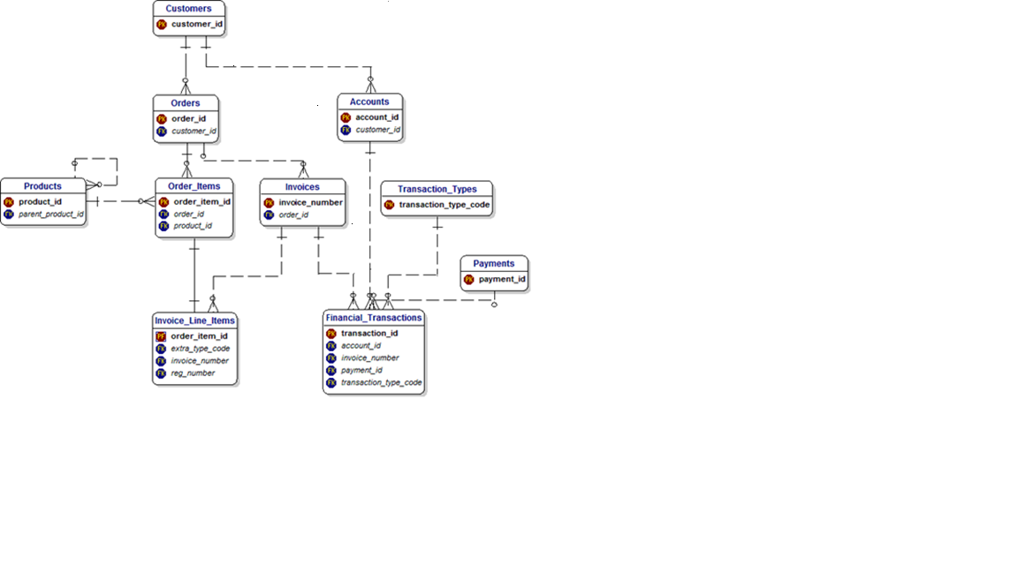

* TRANSPORTATION AND SHIPMENT

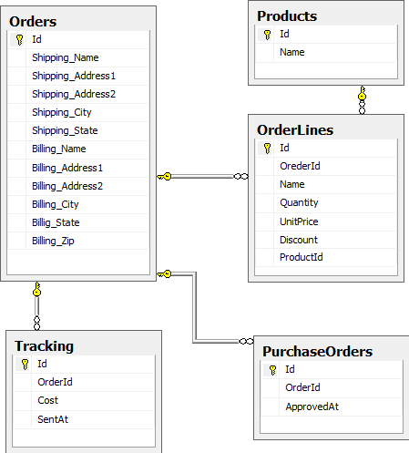

* ORDER,CUSTOMER AND PRODUCT

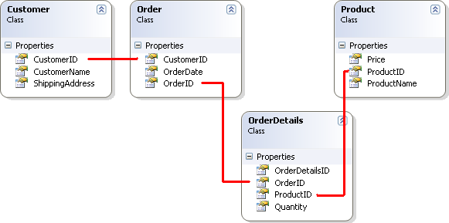

* PAYMENT-CUSTOMER SCHEMA

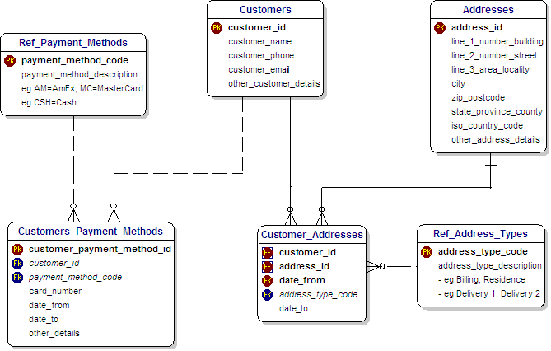

**CLASS RESPONSIBILITY COLLABORATOR**

**(CRC CARDS)**

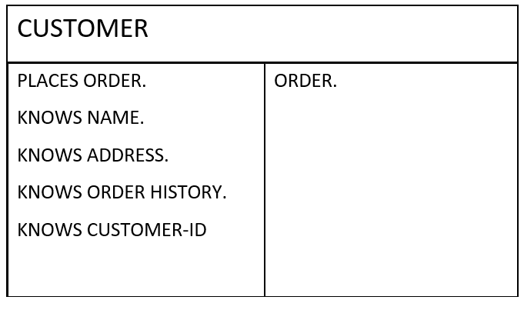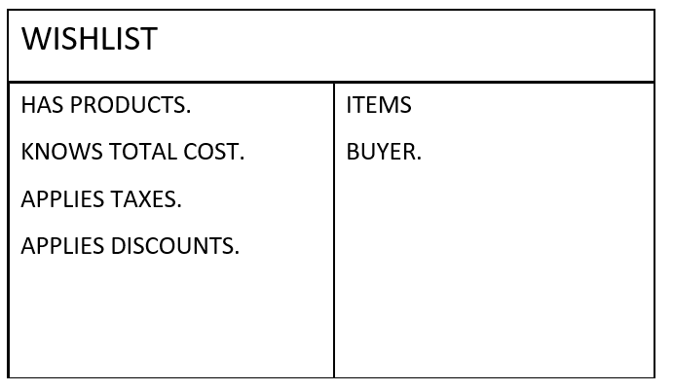

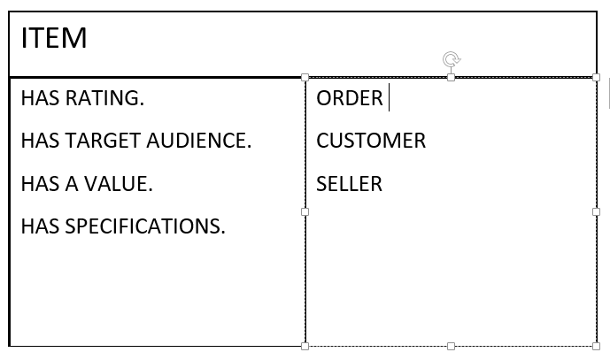

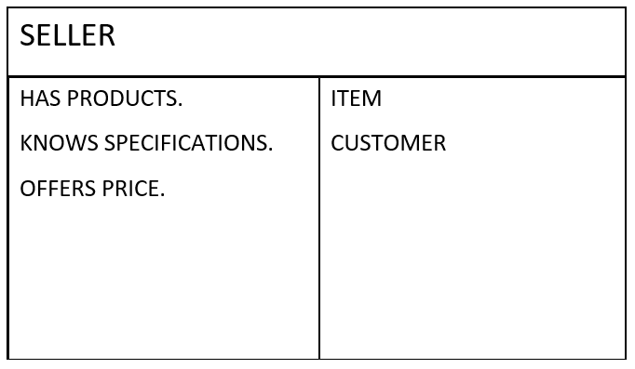

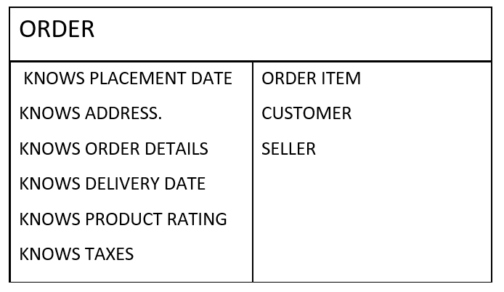

MODELLING

THIS SECTION CONTAINS THE SKETCH OF THE PROJECT WHICH HELPS TO UNDERSTAND THE ARCHITECTURE OF THE PROJECT

**SAMPLE SKETCH**

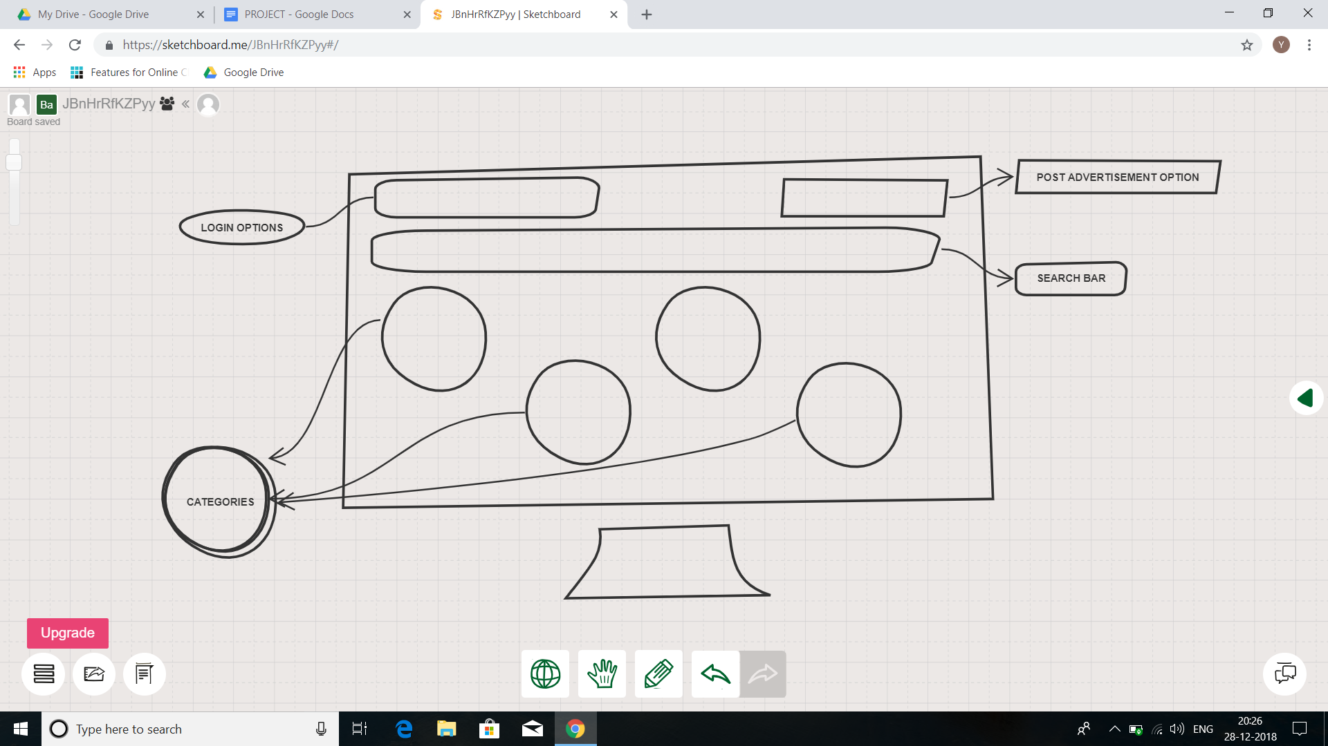

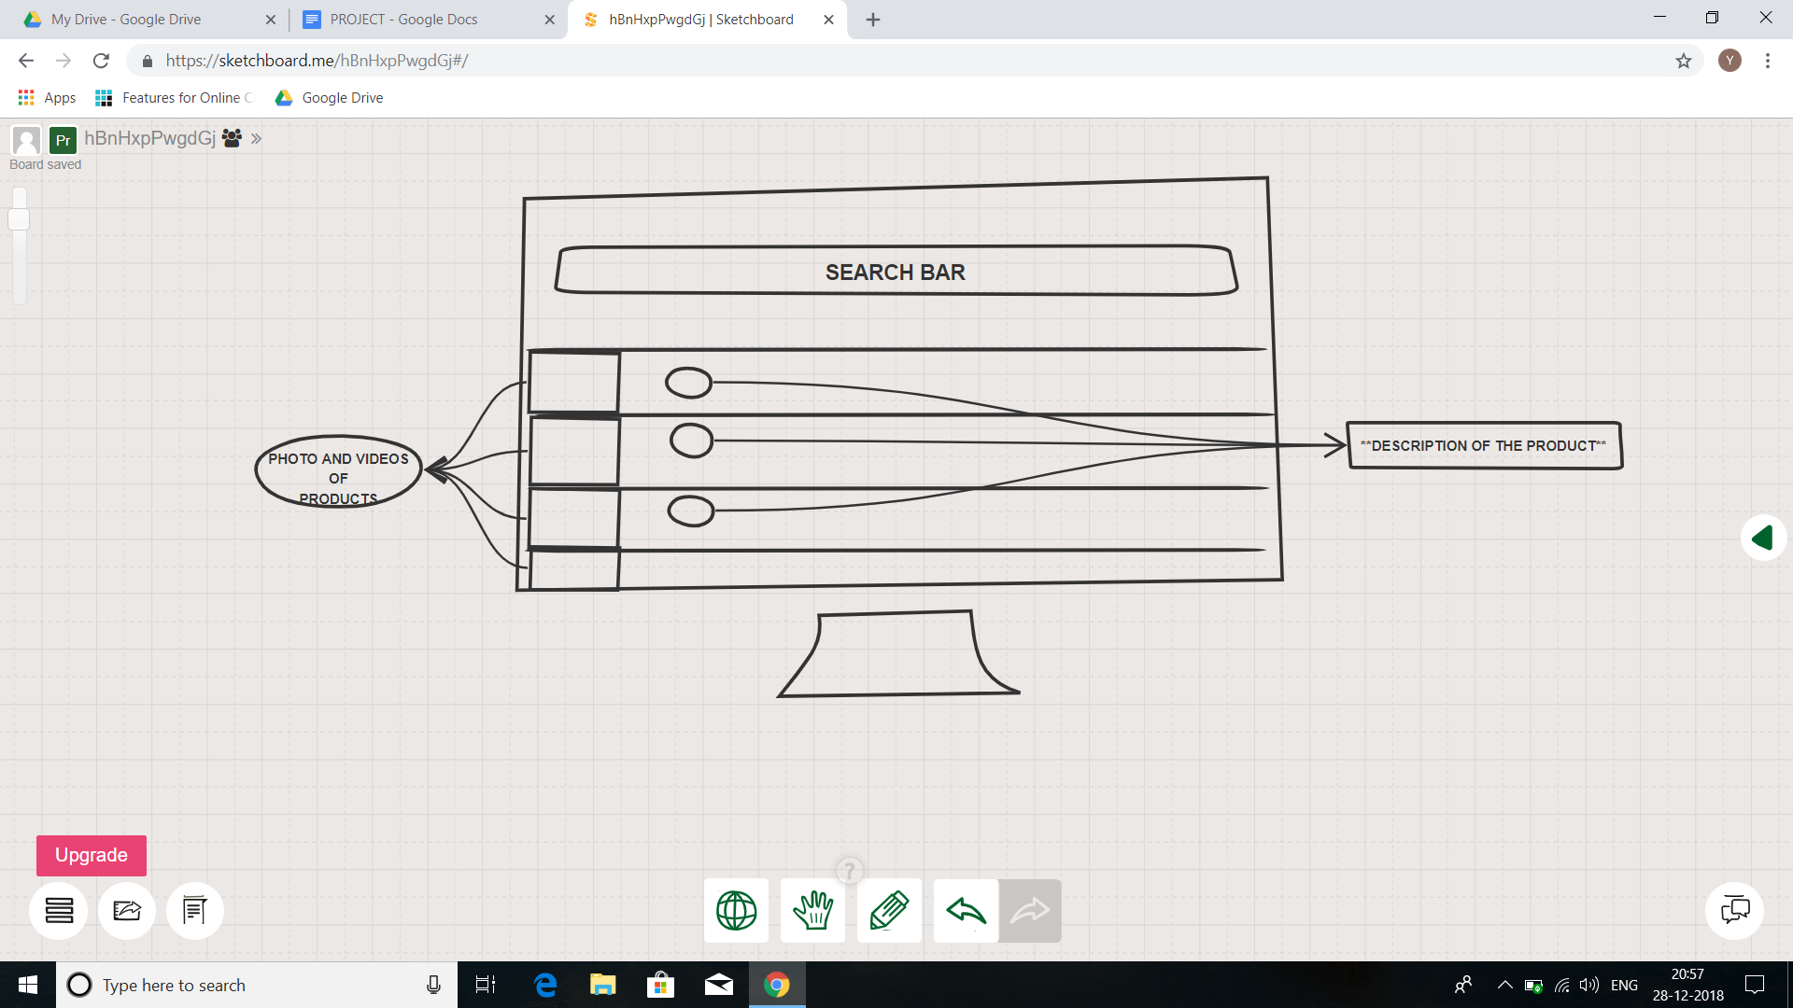

* Homepage:-
  + The homepage will have option for all the categories
  + The top right corner will have the option to post the Advertisement.
  + Top left corner will have the login option or the details of the account holder.
  + By clicking on the category option the user will be taken to the respective page.
* Post Ad:-
  + On clicking the post Ad option on the homepage the user will be taken to this page.
  + Here the seller will have to upload the pictures and videos of the product and fill the other fields
  + After clicking the submit button the action will be taken according to whether the user is premium customer or not and the Ad will be posted within 15 seconds
* Buying :-
  + After selecting the category on the homepage, the user will be taken to a page where he can look and buy those products
  + User will have a option to put the product in the wishlist option
  + User can add the product to the kart and can later buy it
  + There will be an option to contact the seller of the product
  + If the buyer is premium customer , then the delivery will be handled by the stakeholders

CONSTRUCTION

THIS SECTION BRIEFLY DESCRIBES ABOUT THE CODING AND TESTING ACTIVITY CARRIED OUT IN THE DEVELOPMENT PROCESS

**CODING**

* Programming Languages Involved :
* HTML/CSS/Vanilla JS (For FrontEnd)

+

* DJANGO (Python Based Full Stack Web Development Framework)
* HTML/CSS/JS for frontend we are eliminating the need of using any dependencies thus making the portal more optimized and lowering page load times.
* DJANGO for making backend of our portal it reduces load on server, increases the data processing speeds, making website high performant.
* By using this technology stack we make a website which is
  + - **Visually Appealing** : A beautiful user interface in accordance with material design guideline issued by google and consistent color scheme across the whole website.
    - **Highly Scalable** : To meet the heaviest traffic demand thus making the site future proof.
    - **Robust** : Using python as code base for the backend, the portal is highly immune to errors.
    - **Secure** : We’ve made all efforts to make our site highly secure to protect our user’s data from threats such as Sql injections, clickjacking and cross-site scripting.
    - **Mobile friendly** : Our portal is responsive and well optimized even for devices with small screen.
    - **SEO Optimized** : Even minute details have been taken care of to make sure site always lands up at top places in search results.
    - **Accessible** : Special methods have been incorporated to make sure site is accessible by differently abled people.
    - **User Friendly** : Well organised landing page based on User Experience research to reduce bounce rates and thus in turn increasing user conversion rates.

**TESTING**

Homepage :-

* + Is it going to auto scroll?
  + If yes, at what interval will the image be refreshed?
  + When the user hovers over it, is it still going to scroll to the next one?
  + Can it be hovered on?
  + Can it be clicked on?
  + If yes, is it taking you to the right page and right deal?
  + Is it loading along with the rest of the page or loads last in comparison to the other elements on the page?
  + Can the rest of the content be viewed?
  + Does it render the same way in different browsers and different screen resolutions?

Search :-

* + Search Results have to be relevant
  + Different sort options have to be available- based on Brand, Price, and Reviews/ratings etc.
  + How many results to display per page?
  + For multi-page results, are there options to navigate to them

Payment :-

* + Check different payment options
  + If allowing checkout as Guest, simply finish the purchase and provide an option to register at the end
  + Returning customers – Login to check out
  + User sign up
  + If storing customer Credit card or any other financial information, perform security testing around this to make sure it is secure.(PCI compliance is a must)
  + If the user is signed in for a long time, make sure the session is timed out or not. Every site has a different threshold. For some, it is 10 minutes. For some, it might be different.
  + Emails/Text confirmation with the order number generated

Other test:-

* + Login
  + FAQs
  + Contact Us page
  + Customer Service page etc.

**GUI**

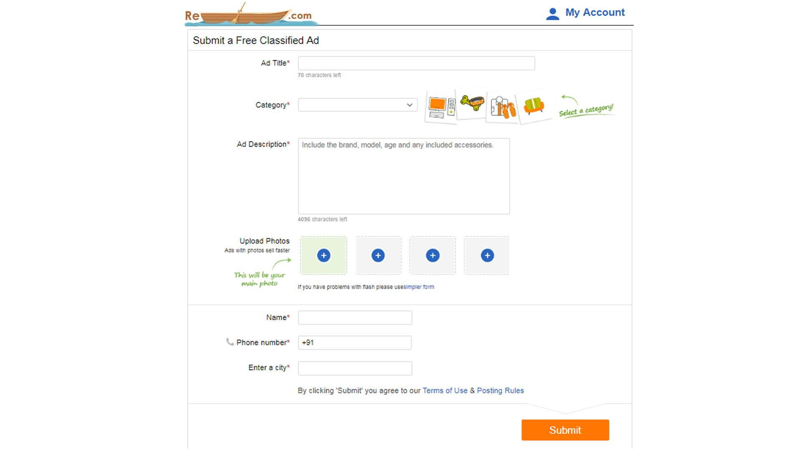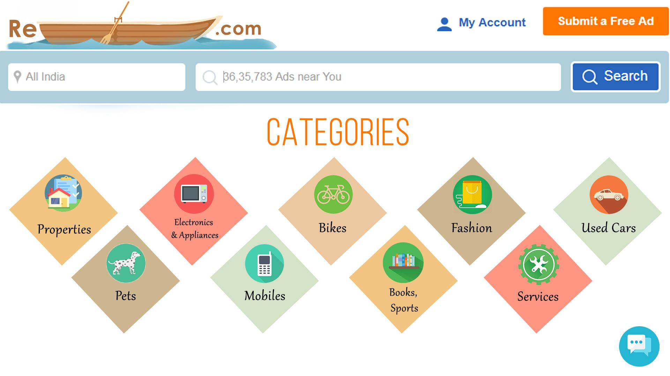

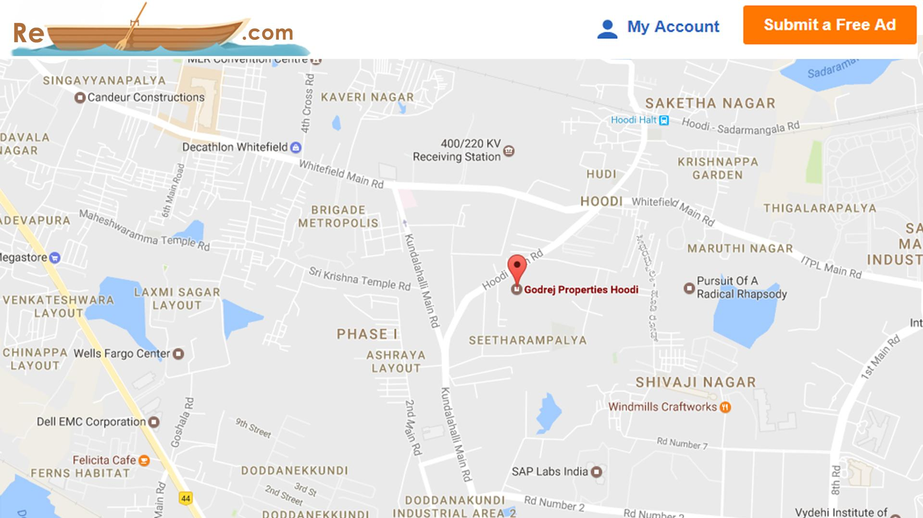

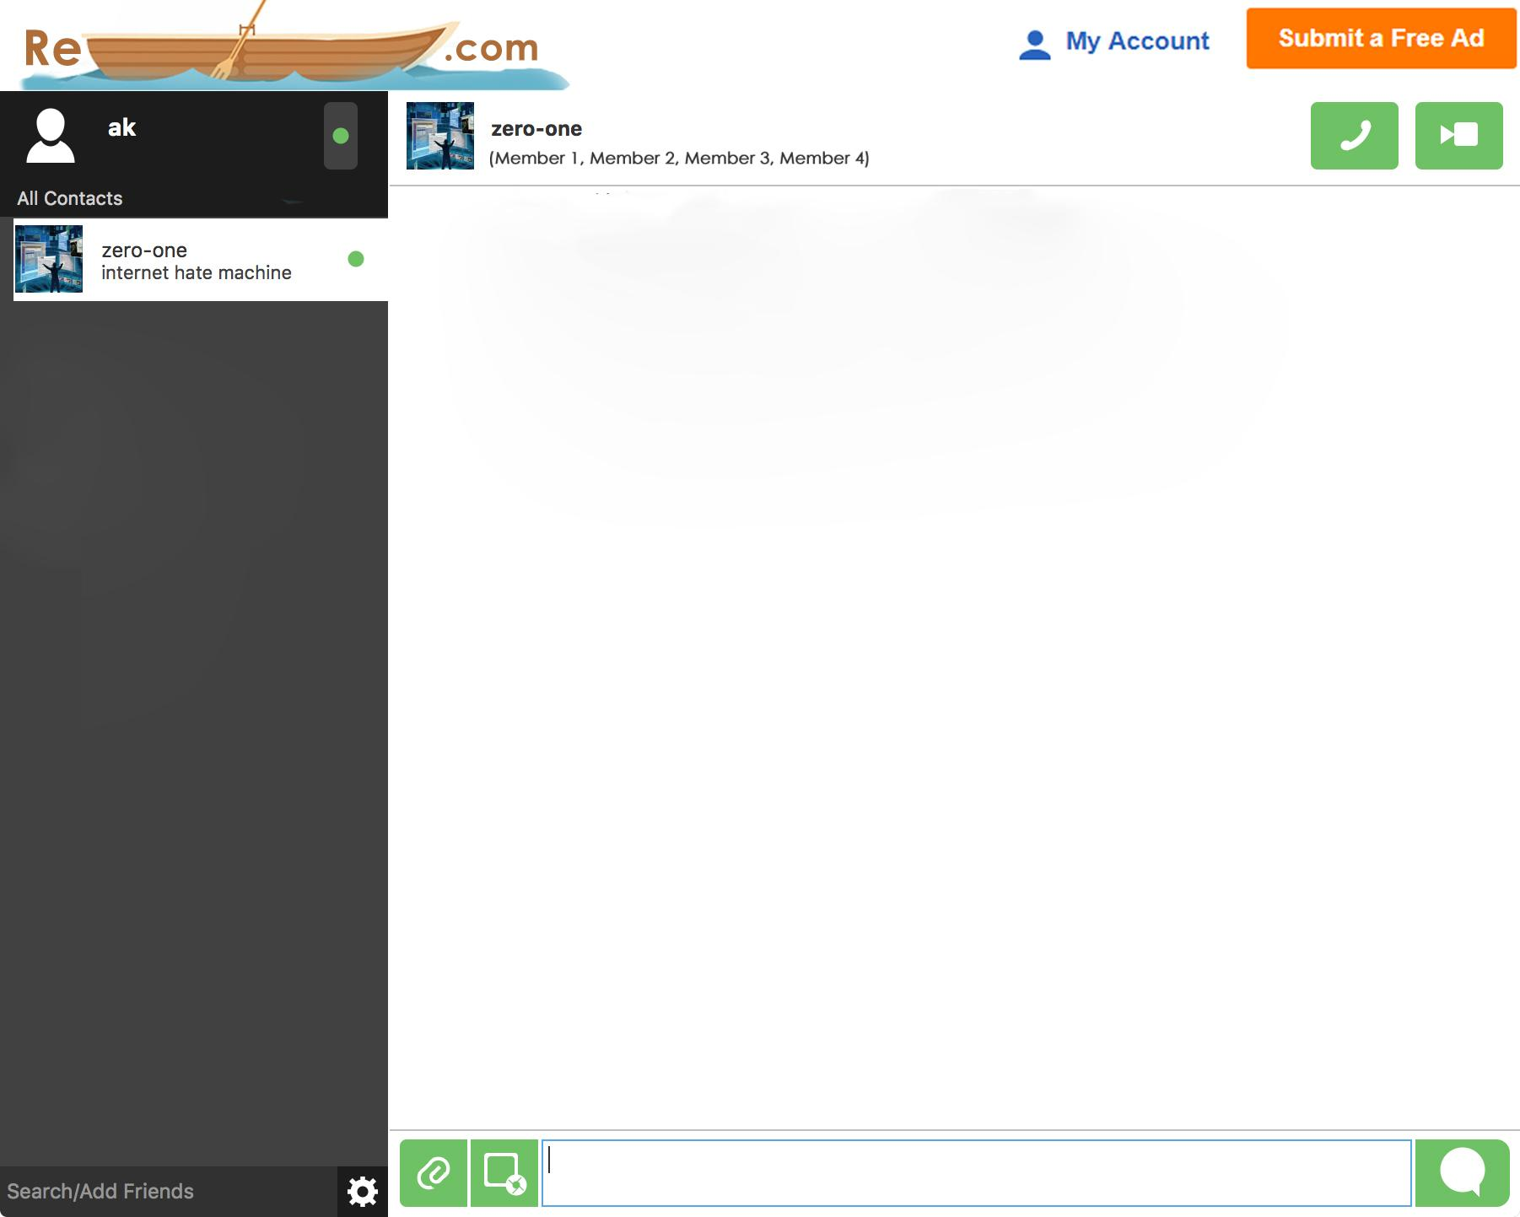

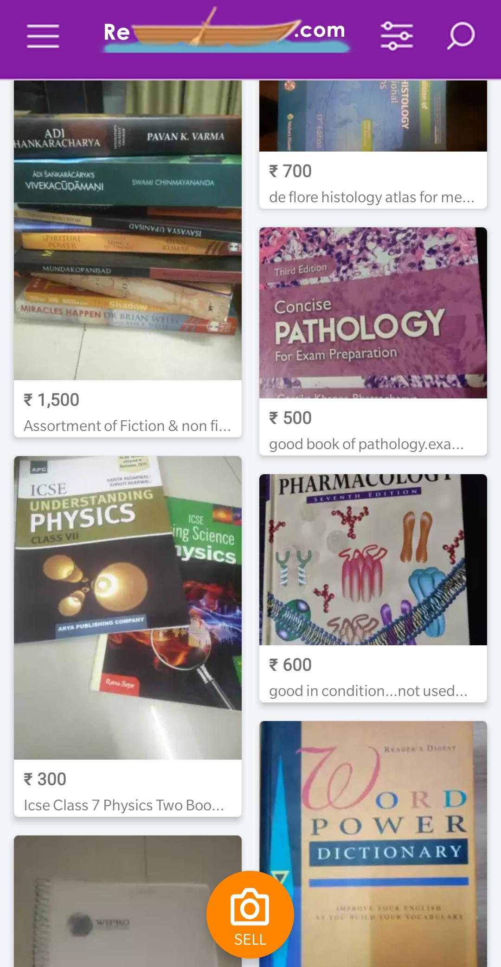

DEPLOYMENT

THIS SECTION CONTAINS THE FEEDBACK FROM THE CUSTOMER AND THE END USERS

**DECLARATION**

*We hereby declare that the portal RESAIL.COM*

*has been successfully delivered to the Helping Hands NGO*

*All the processes involved in development of the software took place under the legal acts.*

*Product Name Product Number Revision Number   
RESAIL Elite G6711AA, G6712AA, G6700AA, G6701AA, 3.3.2 SP1   
G6704AA, G6705AA   
RESAIL SI G6702AA, G6703AA, G4679AA, G4680AA 3.3.2 SP1   
G2801A Opt. 610   
G2802A Opt. 610   
G2805A Opt. 610   
   
   
was developed according to the quality process and software life cycle followed by the Life Science   
and SOFTWARE Analysis divisions OF WIREFRAME Technologies. Life cycle check-point details were   
reviewed and approved by management. The product was found to meet its functional and   
performance specifications, and release criteria at release to shipment. In order to fulfill the   
validation requirements of the users of this product according to current regulations and quality   
standards including, but not limited to, 21 CFR 210 (Good Sale portal), 21   
CFR 211 (current Good buying Practice for reusable products), 21 CFR 58 (Good   
Portal trade Practice), Wireframe software developers has made the source code and the documents   
referenced above of this declaration to "Helping hands"  
NGO association for inspection as well as use at its respective facility (terms and conditions to be negotiated).   
Wireframe technologies will maintain possession of all documents and their reproductions and may   
require a confidential disclosure agreement to be provided by those requiring access to these   
documents other than the organisation involved in the procedure.  
   
   
Date: December, 2018  
   
   
 Management:   
   
 Negotiation Manager  
 Swasti Karia  
Quality Manager   
Mihir Bhanushali  
Project Head  
Pranav Padhiyar  
Rahul Singh  
Developers Incharge  
Krunal Pancholi  
Prathamesh   
Wireframe, Inc.*

*Associate with  
Co-founder  
Shubham Soni  
Neel Shah  
Nancy Karia  
Yash Babel*

*Helpinghand.org  
   
Lifecycle Phase Transition Approvals   
   
Proposal   
Investigation   
Implementation   
Test   
Manufacturing Release   
   
Software Quality Assurance   
   
Quality Plan   
Release Criteria   
Software Test Plan   
Test Procedures   
Test Results   
Test traceability to requirements   
System change request tracking and reporting   
   
Documentation and Change Management   
   
Requirements Management   
Software Configuration Management   
Coding Standards   
   
Source Code   
   
   
 Wireframe Technologies, Inc.   
5301 A State X city  
, CA 95051*

**---------------**

**FEEDBACKS**

